**Screenshot 1 – 3.3V output voltage, vertical axis 1V/div**

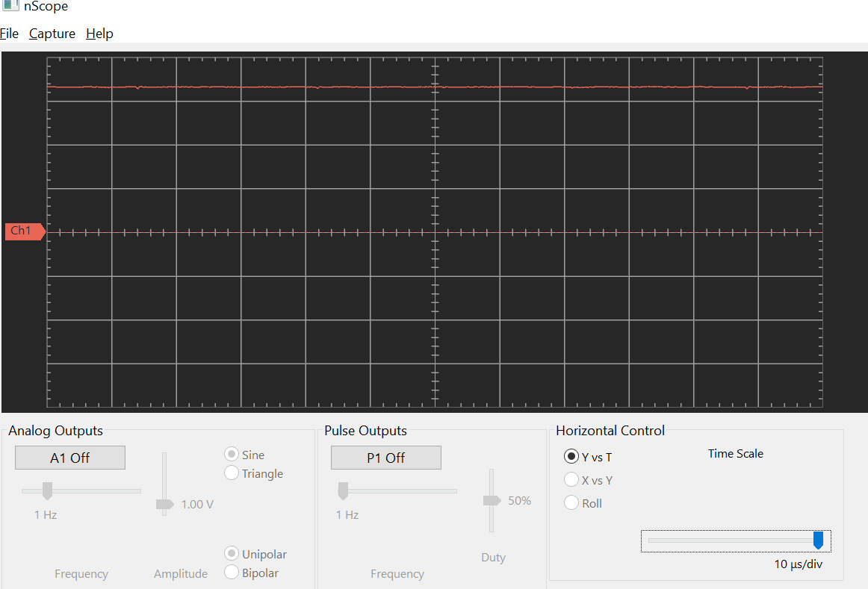

**Screenshot 2 – 3.3V output voltage, LED added, vertical axis 1V/div**

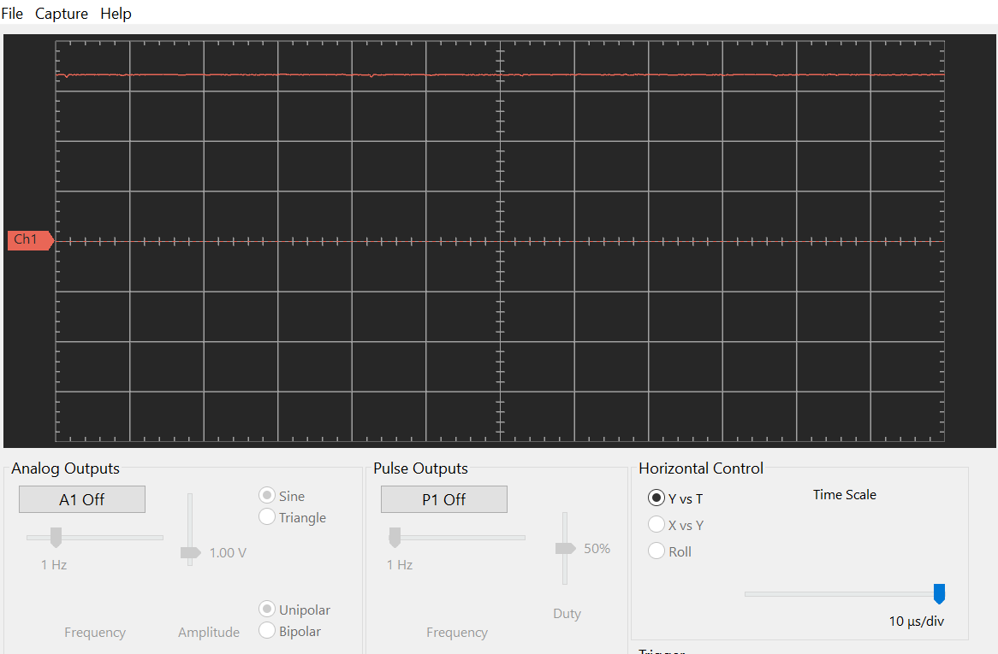

**Screenshot 3 – 3.3V output voltage, bypass capacitors added, vertical axis 1V/div**

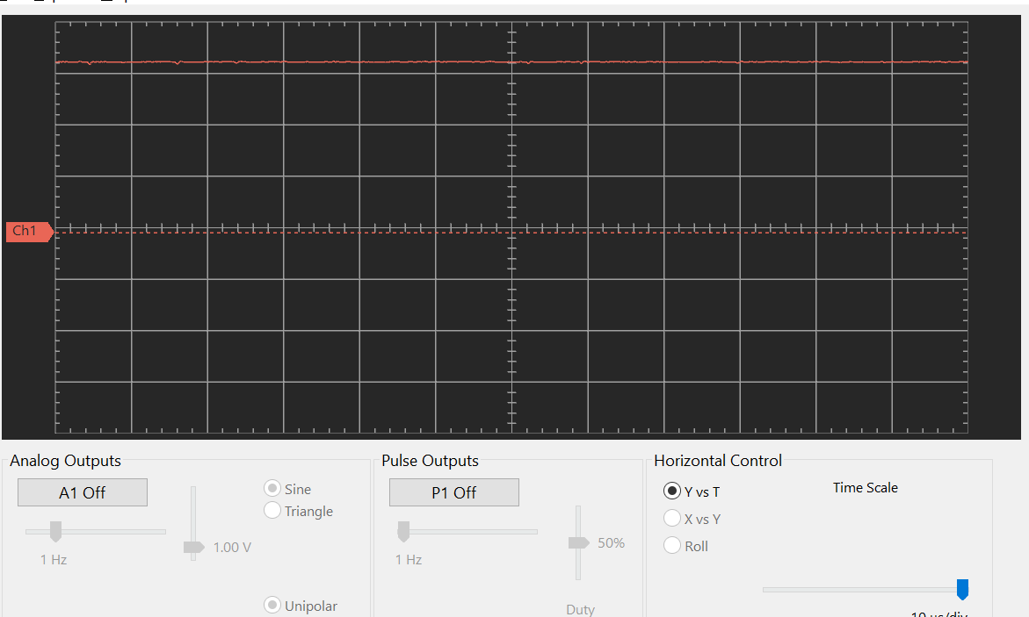

**Photo of circuit diagram**

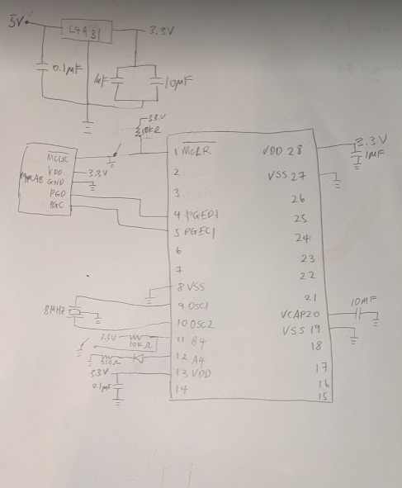

**Photo of circuit**

